ASSIGNMENT 2: DEFECTS RAISED BY VIKAS BHARDWAJ

TITLE -: Something wrong about password (I : e password visible in plain text while typing.)

Priority -: High
Severity -: Critical
STEPS -: 1. Open login page
2.Use vk88574 username
3.Type password @vkb88574 in password field
EXPECTED RESULT -: password should be hidden with dots.
ACTUAL RESULT -: Password is visible as plain text.
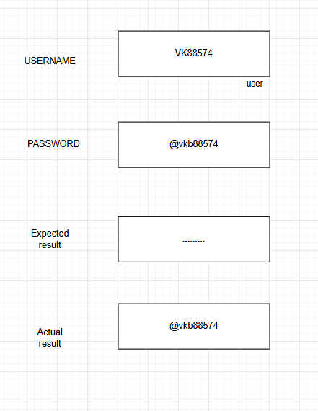

2. TITLE -: User is able to login with invalid password
Priority -: High
Severity -: High
Steps-: 1. Open the application
2. Enter username : upsc01
3. Enter password : abc123clear(invalid)
4. Click on login button
Expected result: System should display error message; invalid username or password
Actual result: User is successfully logged in and redirected to dashboard
Attachmentl: Screenshot.jp

3. TITLE-: FORGOT PASSWORD TEXT IS MISSPELLED ON LOGIN PAGE

Priority -: low
Severity-: low
Steps-: 1. Open login page
2. Observe the link text
Expected Result: There should be Forgot password
Actual result: Text is displayed as "Forogt Password"
Attachment: Screenshot.jpg

